

**Provision ATCOM phones by PNP**

Version: 1.0

2019-3-1

Contact ATCOM

Overview of ATCOM

ATCOM is the leading VoIP hardware manufacturer in global market. We have been keeping innovating with customer’s needs oriented , working with partners to establish a total solution for SMB VoIP with IP phone , IP PBX and Asterisk cards  
  
With over 10 years’ experience of R&D , manufacturing and service in network and VoIP filed ; mission of creating the biggest value for IP terminals , we commit ourselves in supplying the competitive IP phone and other terminals for IP PBX , softswitch , IMS , NGN providers and carriers; supplying the competitive total VoIP solution for SMB market. We keep improving the customer’s experience and creating the bigger value with our reliable products. Until now, our VoIP products have been available in 100+ countries and used by millions of end users.

**Contact Sales**

|  |  |
| --- | --- |
| Address | Area C, A2F , Block 3 ,Huangguan Technology Park , #21 Tairan 9th Rd, Chegongmiao , Futian District , Shenzhen China |
| Tel | + (86) 755-83018618-1 |
| Fax | + (86) 755-83018319 |
| E-mail | [sales@atcom.com.cn](mailto:sales@atcom.com.cn) |

**Contact Technical Support**

|  |  |
| --- | --- |
| Tel | + (86) 755-83018618-2 |
| E-mail | [Support@atcom.com.cn](mailto:Support@atcom.com.cn) |

**Website Address**: <http://www.atcom.cn/>

Auto provision PNP(Plug and Play) introduce

When Atcom IP phone power up and get the network, the phone can request to the server to obtain a provision URL, and finish the phone auto provision feature.

PNP auto provision process:

1. The phone default enable the PNP feature, the detail please refer **The PNP step1**.

2. It could send the Subscribe multicast packet by repeatedly, the detail please refer **The PNP step2**.

3. The PBX can received the subscribe multicast packet, and if can match the subscribe info, then it would back notify info with the provision URL, the detail please refer

**The PNP step3**.

4. Then the phone back the 200OK, and download the phone provision configure file from the provision URL, the detail please refer **The PNP step4**.

**The PNP step1**

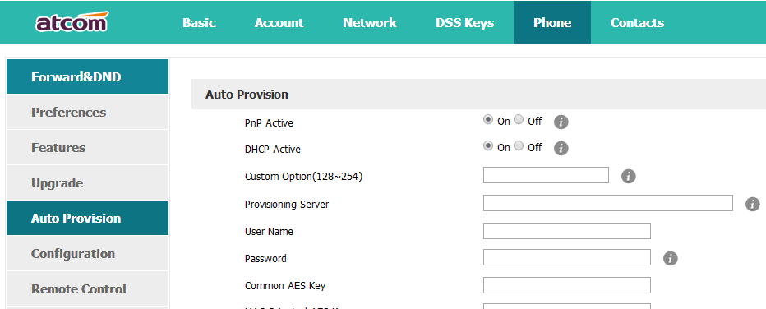

Plug and Play (PnP) is one of the auto provision way and based on SIP protocol, the phone default enable the PNP feature, when the phone power up and get the network, it would send the subscribe info use multicast way by repeatedly, if the PBX can compatibility support the multicast subscribe info, it could response 200 OK, and the back the sip notify info with the auto provision configure URL, then the phone can download the provision configure file from the URL.

**The PNP step2**

Atcom would send the subscribe info use multicast way by repeatedly

**Subscribe message:**

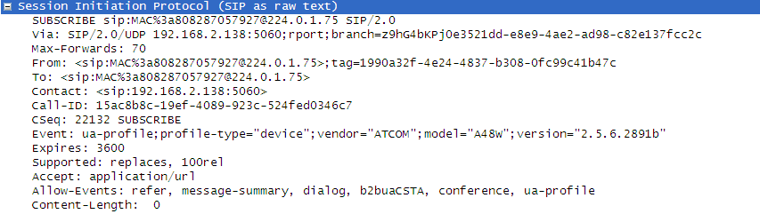

**The PNP step3**

If the PBX can compatibility support the multicast subscribe info, it could response 200 OK, and the back the sip notify info with the auto provision configure URL

Notify message:

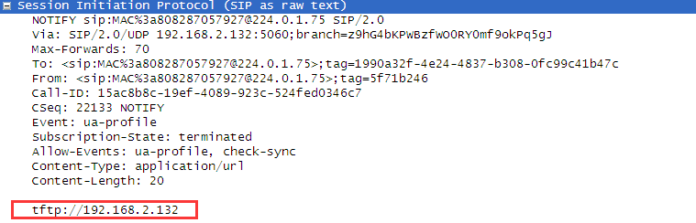

Please check as above photo: the message body with the provision URL: tftp://192.168.2.132

The phone can supports http/ftp/https/tftp server, the auto provision guide please refer《Atcom provision user manual》.

**The PNP step4**

Atcom IP phone received and back 200OK, then download the provision configure file from the URL

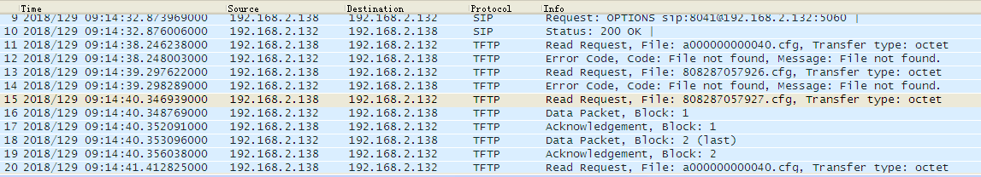

Auto Provision configure file:

There are two configure file: Common.cfg and MAC.cfg

.Commom.cfg can use for all the same model.

A1X：a000000000010.cfg

A2X：a000000000020.cfg

A41：a000000000041.cfg

A48：a000000000048.cfg

A68：a000000000068.cfg

CT11: a000000000011.cfg

D2X：d000000000020.cfg

D3X: d000000000030.cfg

.Mac.cfg ,every IP phone has own MAC address can deploy one single IP phone.

For example: one A11 Phone MAC address is 808287010203, so the mac.cfg and renamed 808287010203.cfg

Please refer《Atcom provision user manual》。