

**ATCOM phone provisioning user manual**

Version: 3.0

2021-9-2

Contact ATCOM

Overview of ATCOM

ATCOM is the leading VoIP hardware manufacturer in global market. We have been keeping innovating with customer’s needs oriented , working with partners to establish a total solution for SMB VoIP with IP phone , IP PBX and Asterisk cards  
  
With over 10 years’ experience of R&D , manufacturing and service in network and VoIP filed ; mission of creating the biggest value for IP terminals , we commit ourselves in supplying the competitive IP phone and other terminals for IP PBX , softswitch , IMS , NGN providers and carriers; supplying the competitive total VoIP solution for SMB market. We keep improving the customer’s experience and creating the bigger value with our reliable products. Until now, our VoIP products have been available in100+ countries and used by millions of end users.

**Contact Sales**

|  |  |
| --- | --- |
| Address | Area C, A2F , Block 3 ,Huangguan Technology Park , #21 Tairan 9th Rd, Chegongmiao , Futian District , Shenzhen China |
| Tel | + (86) 755-83018618-1 |
| Fax | + (86) 755-83018319 |
| E-mail | sales@atcom.com.cn |

**Contact Technical Support**

|  |  |
| --- | --- |
| Tel | + (86) 755-83018618-2 |
| E-mail | [Support@atcom.com.cn](mailto:Support@atcom.com.cn) |

**Website Address**: <http://www.atcom.cn/>

Content

Contact ATCOM 2

Overview of ATCOM 2

How to provision ATCOM IP Phone 4

1. Introduction 4

2. Obtaining Configuration Information 4

2.1. Obtaining Configuration Files： 4

2.2. Obtaining phone information： 5

3.Managing Configuration Files 5

3.1. Editing Common CFG file： 6

3.2. Editing MAC-Oriented CFG file： 26

4. Configuring a TFTP Server 38

4.1 Preparing a Root Directory 38

4.2 Configuring a TFTP Server 40

5. Obtaining the Address of provisioning file 40

6. Downloading and Verifying Configuration 42

How to provisioning ATCOM IP Phone

This guide shows user how to provisioning ATCOM IP phones with the minimum settings required.

The purpose of this guide is:

•Be unfamiliar with atcom IP Phone

•Provisioning mass atcom IP phones

•ATCOM IP Phones support the TFTP, FTP, HTTP and HTTPS protocols for file.

Provisioning are configured by default to use Trivial File Transfer Protocol(TFTP)

## Introduction

This sections shows user how to get ready for the provisioning. The provisioning process discussed in this guide uses TFTP and a personal computer (PC) as the provisioning server.

The purpose of this guide is to serve as a basic guidance for auto provisioning Atcom IP phones, including:

A1x, A2x, A41, A4x, A6x,CT11,D2X,D3X

### Obtaining Configuration Information

### Obtaining Configuration Files：

Before beginning provisioning, user needs to obtain the configuration files. There are 2 configuration files both of which are CFG formatted. We call these two files **Common CFG file** and **MAC-Oriented CFG file**. The phone will try to download these CFG files from the server during provisioning.

The MAC-Oriented CFG file is only effectual for the specific phone. It uses the 12-digit MAC address of the phone as the file name. For example, if the MAC address of the phone is 80828701E160, then the MAC-Oriented CFG file name must be 80828701E160.cfg.

However, the Common CFG file is effectual for all the phones with the same model. It uses a fixed name “a00000000000x.cfg” as the file name. the names of the Common CFG file for

A1X is ‘a000000000010.cfg’;

A2X is ‘a000000000020.cfg’;

A41 is ‘a000000000041.cfg’;

A4X is ‘a000000000040.cfg’;

A6X is ‘a000000000060.cfg’;

CT1X is ‘a000000000011.cfg ;

D2X is ‘d00000000020.cfg’

D3X is ‘d00000000030.cfg’

A1X model included A10, A11, A16

A2X model include A20, A21, A20LTE, A20W, A20WAC, A26

A41 model include A40, A41, A41W

A4X model include A48, A48WAC, A48W, A48LTE

A6X model include A68, A68WAC, A68W, A68LTE

D2X model include D21, D22

D3X model include D32, D33

### Obtaining phone information：

Before beginning the provisioning, user will also need the phone information. Such as,

MAC address and the SIP account of the phone.

**MAC Address**: The unique 12-digit serial number of the phone. You can obtain it from the

phone’s bar code at the back of the phone.

**SIP Account**: This may include SIP credentials such as user name, password and the

address of the phone’s registration server . Ask system administrator for SIP account

information user need. Although SIP accounts may not be required to get the phone

working, we strongly recommend using them.

### Managing Configuration Files

Auto provisioning enables Atcom IP phones to update automatically via downloading the Common CFG file and MAC-Oriented CFG file.

(the provisioning configuration of Common.cfg and MAC.cfg can be exchanged each other)

Before provisioning user may need to edit and customize the configuration files.

### Editing Common CFG file：

Common CFG file contains configuration parameters which apply to all phones of the same phone model.

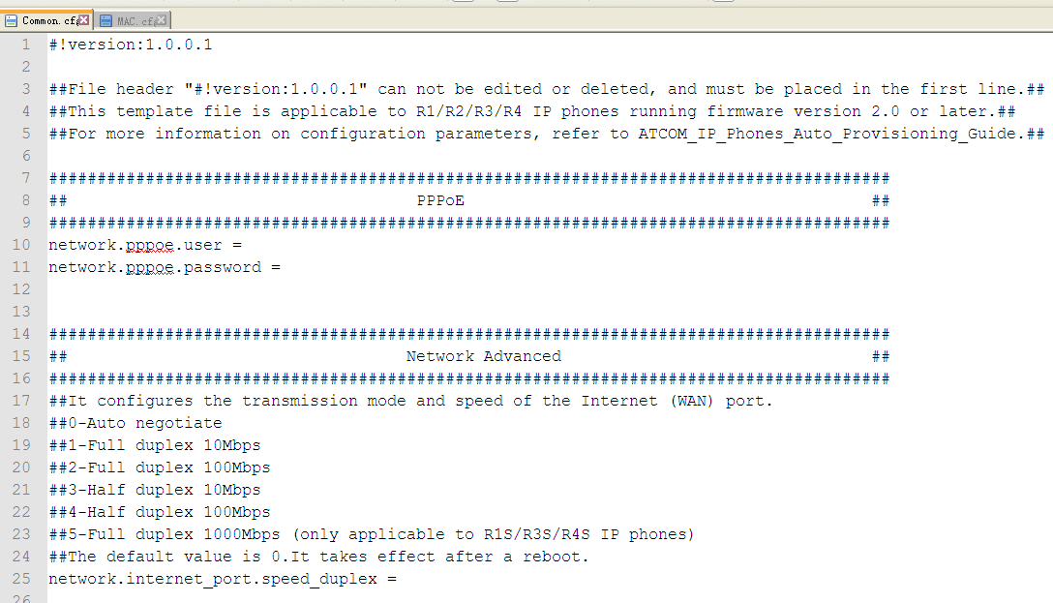

Note:

The line beginning with “#” is considered to be a comment.

The file header “#!version:1.0.0.1” is not a comment, it must not be edited or be deleted and must be placed in the first line.

The parameters commonly edited in the Common CFG file are detailed as following link:

<http://download.atcom.cn/phone/Guidedocument/auto_provision/Common.cfg>

### Editing MAC-Oriented CFG file：

MAC-Oriented CFG file contains configuration parameters which are expected to be updated per phone, such as the registration information.

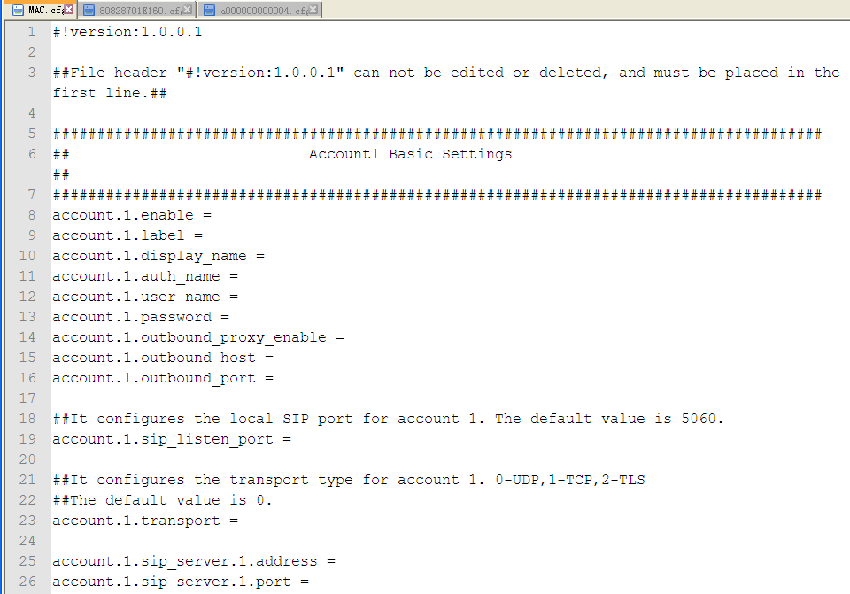

The parameters commonly edited in the MAC-Oriented CFG file.

#!version:1.0.0.1

##File header "#!version:1.0.0.1" can not be edited or deleted, and must be placed in the first line.##

The parameters commonly edited in the MAC.CFG file are detailed as following link:

<http://download.atcom.cn/phone/Guidedocument/auto_provision/MAC.cfg>

## Configuring a TFTP Server

Atcom IP Phones support using the FTP, TFTP, HTTP and HTTPS protocols to download the

configuration files.

TFTP server is used by default. You can use any protocol for provisioning. The following section takes the TFTP server as an example.

We recommend that user can use tftpd or 3CDaemon tool as a TFTP server. tftpd is free applications for Windows. user can download the TFTPD32 at: http://tftpd32.jounin.net/

### 4.1 Preparing a Root Directory

To prepare a root directory

1. Create a root TFTP directory on the local computer
2. Place the configure file to this directory
3. Set the security permissions for the TFTP directory folder

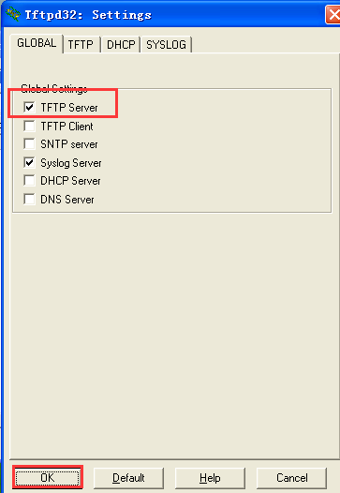

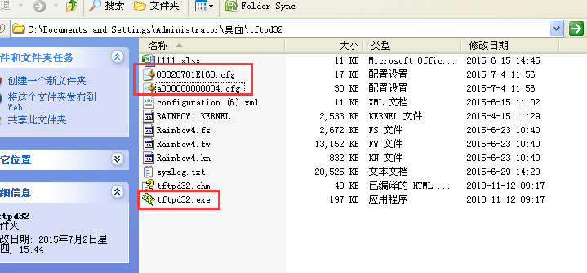

### 4.2 Configuring a TFTP Server

If you have a tftpd32 application installed on your computer, use it directly.

If tftpd32 start to download the provisioning file, please check as following screenshot

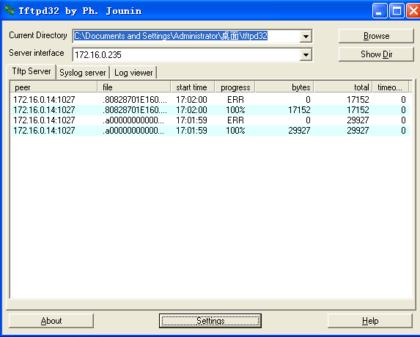

## 5. Obtaining the Address of provisioning file

Atcom IP phone support to obtain the provisioning server during boot up process in the following ways:

1. Auto provision by the webpage
2. DHCP Option
3. Plug and Play (PNP) server
4. RPS website

1.To configure the auto provisioning by the webpage .

login to webpage by admin lever (the right corner) ,and go to ‘Update-Auto Provision’,

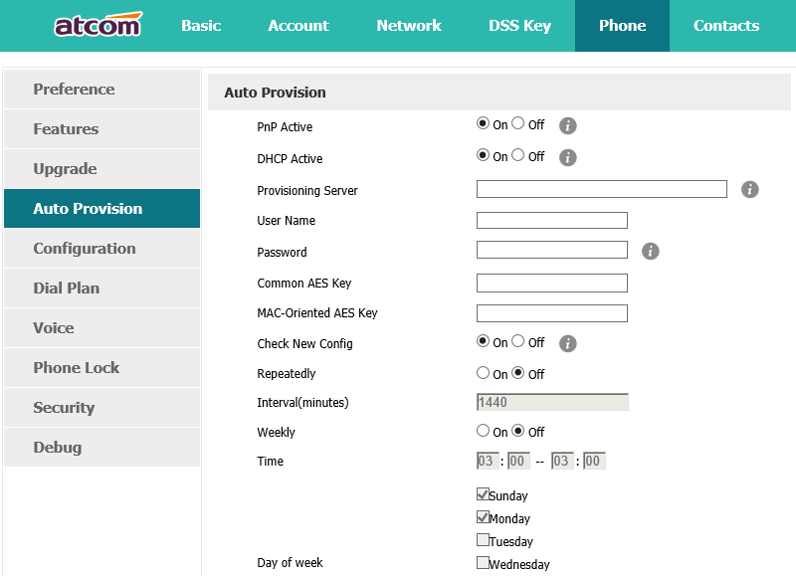

2.To configure DHCP option

Please check the DHCP option detailed from the guide document, you can download as below link:

<http://download.atcom.cn/phone/Guidedocument/auto_provision/How_to_Provision_ATCOM_Phones_by_dhcp_option.pdf>

3.To configuration PNP server

Atcom IP phone default enable PNP server, please check the guide document from as below link:

<http://download.atcom.cn/phone/Guidedocument/auto_provision/How_to_Provision_ATCOM_Phones_by_PNP-EN.docx>

Any PNP sever activated in the network responses with a SIP Notify message and an address of the provisioning server contained in the message body. The phone can then connect to the provisioning server and performs the provisioning process

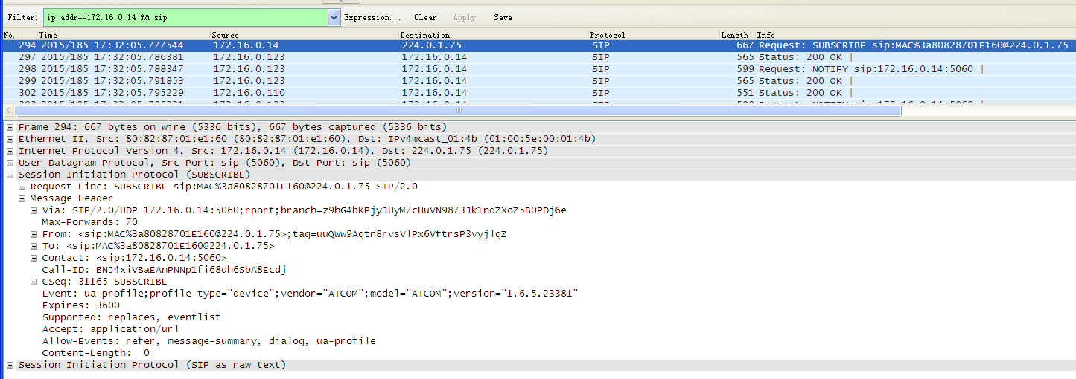

4.To configure RPS website

please check the RPS website detailed guide document, please check as below link:

<http://download.atcom.cn/phone/Guidedocument/auto_provision/How_to_provisioning_server_by_RPS.pdf>

## 6.Downloading and Verifying Configuration

During the auto provisioning process, you can monitor the download request and response message by a wireshark tool.

Atcom IP phone downloads configuration files from the tftp server.

